**Sprint 2 - Accuracy Design Document**

**November 16, 2022**

## ***Project Overview***

The robot must successfully run the figure eight course 5 times. A path will be laid  
out on the floor. The robot must stay within the path provided. The robot will start and finish  
in the square provided. Upon finishing, robot will speak ‘I am the winner’ and flash multicolored  
lights for 5 seconds. Points will be deducted if the robot strays from the path, if it does not go  
around 5 times, or if it does not finish in the same place it started.

## ***Purpose and Scope of this Specification***

The purpose of the project is to successfully complete the accuracy test.

**In scope**

* Accuracy Test

**Out of Scope**

* Endurance Test
* Agility Test

# Product/Service Description

## ***Product Context***

This project is one part of three tests which will test the robot in three different categories; endurance, accuracy, and agility.

## ***User Characteristics***

* Student
* Faculty Member

## ***Assumptions***

The robot being used is the Sphero+.

## ***Constraints***

Describe any items that will constrain the design options, including

* Can only use assigned block coding
* Set track
* Only one type of robot

## ***Dependencies***

* Objects in its path
* Speed of the robot

# Requirements

## ***Functional Requirements***

|  |  |  |  |  |  |
| --- | --- | --- | --- | --- | --- |
| **Req#** | **Requirement** | **Comments** | **Priority** | **Date Rvwd** | **SME Reviewed / Approved** |
| ACCUR_01 | Complete figure 8 five times. |  | 1 | 11/16/22 | Jason |
| ACCUR_02 | Stay within the path provided |  | 1 | 11/16/22 | Jason |
| ACCUR_03 | Upon finishing the robot must speak “I am the winner” |  | 1 | 11/16/22 | Jason |
| ACCUR _04 | Flash multicolored lights while speaking for 5 seconds |  | 1 | 11/16/22 | Jason |
| ACCUR _05 | Finish at the same spot the robot started |  | 1 | 11/16/22 | Jason |

## ***Security***

### **Protection**

* Encryption
* Activity logging

### **Authorization and Authentication**

Specify the Authorization and Authentication factors.

## ***Portability***

|  |  |  |  |  |  |  |  |
| --- | --- | --- | --- | --- | --- | --- | --- |
| **Feature** | **Description** | **IOS** | **Android** | **Chrome OS** | **Fire OS** | **Windows** | **macOS** |
| **System Requirements** | The minimum operating system, browser, or required hardware for each platform. | **OS Requirements:** **iOS 12.5.6+**  **Additional Requirements:** **Bluetooth 4.0+** | **OS Requirements:** **Android 8+**  **Additional Requirements:** **Bluetooth 4.0+** | **OS Requirements:** **Android 8+**  **Additional Requirements:** **4GB memory** **Bluetooth 4.0+** | **OS Requirements:** **Fire OS 7+**  **Additional Requirements:** **Bluetooth 4.0+** | **OS Requirements:** **Windows 10 2004(20H1)+** **Windows 11**  **Additional Requirements:** **64-bit** **4GB memory** **Bluetooth 4.0+** | **OS Requirements:** **macOS 10.15+**  **Additional Requirements:** **Bluetooth 4.0+** |

# Requirements Confirmation/Stakeholder sign-off

|  |  |  |
| --- | --- | --- |
| **Meeting Date** | **Attendees (name and role)** | **Comments** |
| 11/16/22 | Jason, Nicholas, Michael | Teammates worked together well |

# System Design

## ***Algorithm***

https://docs.google.com/document/d/1N9eRlU7mMPY9DecrQXbZlHkpobttWC3VBrpvoEjkbn8/edit?usp=sharing

## ***System Flow***

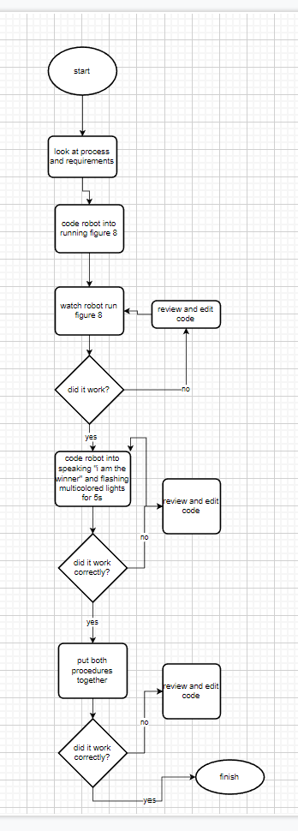

## ***Software***

Robot block coding (JavaScript)

## ***Hardware***

The physical robot (Sphero+)

## ***Test Plan***

|  |  |  |  |  |  |
| --- | --- | --- | --- | --- | --- |
| **Reason for Test Case** | **Test Date** | **Expected Output** | **Observed Output** | **Staff Name** | **Pass/Fail** |
| Trying code for first time | 11/16 | Some small issues but overall not terrible | Deviated heavily from path | Michael Cozzolino, Nicholas Stevens | fail |
| Trying edited code | 11/16 | An improvement in some way | Was able to stay on the path for longer before deviating | Michael Cozzolino, Nicholas Stevens | fail |
| Editing code again | 11/16 | A small improvement | Was able to stay on the path for far longer than before | Michael Cozzolino, Nicholas Stevens | fail |
| Edited code | 11/16 | Stayed on the path for the entire time | Was able to stay on the path for the entire time | Michael Cozzolino, Nicholas Stevens | Pass! |

## ***Task List/Gantt Chart***

[sprint2.xlsx](https://live365monmouth-my.sharepoint.com/:x:/g/personal/s1339198_monmouth_edu/EWkAZdi_Bj9FqxYLYq7nEOcBiMYFGQAHtacZqP_FFUdl6A?e=aIUxkc)

## ***Staffing Plan***

|  |  |  |  |
| --- | --- | --- | --- |
| Name | Role | Responsibility | Reports To |
| Michael Cozzolino | Manager | Overviews project | Nicholas Stevens |
| Nicholas Stevens | Programmer | Creates and designs the code | Michael Cozzolino |
| Jason Galvao | Documenter | Edit and update documents | Michael Cozzolino |